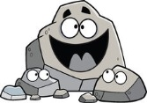
Rocks and Minerals Learning Targets
Target | Before we start | With Help | On My Own | Teach It
1. I know that hardness, color, luster, and streak are physical properties of minerals.
2. I can use the Mohs’ Hardness Scale to predict the hardness of a mineral.
3. I can use the physical properties hardness, color, luster, and streak to identify specific minerals.
4. I can test the physical properties of minerals.
5. I can describe how a metamorphic rock is formed.
6. I can describe how an igneous rock is formed.
7. I can describe how a sedimentary rock is formed.
8. Using the rock cycle I can correctly predict what processes will produce each type of rock.
Study your vocabulary flashcards for this unit.
Target 1:

Target 2:
-Purpose of Mohs’ Hardness scale is to test whether one mineral will _____________ another.
-Range of Mohs’ Hardness Scale: __________________________________________________
-Softest mineral on scale:__________________ Hardest mineral on scale:__________________
Hardness of Common Minerals
Mineral | Hardness
topaz | 8
calcite | 3
galena | 2.5
quartz | 7
feldspar | 6
-If you have an unknown mineral with a hardness of 5, circle all the minerals in the chart that it will NOT scratch.

Targets 3 & 4:
Mineral | Hardness | Color | Streak | Luster | Density | Other
Calcite | 3.0 | clear, white, pink | white | glassy | 2.7 | fizzes in acid
Corundum | 9.0 | white, brown, red | white | glassy | 4.0
Gold | 2.5–3.0 | bright yellow | golden yellow | metallic | 19.0
Gypsum | 2.0 | clear, white, gray | white | glassy to pearly | 2.32
Halite | 2.5 | clear, white | white | glassy | 2.2 | fluorescent
Magnetite | 6.0 | black | black | metallic | 5.2 | magnetic
Pyrite | 6.0–6.5 | bright gold, gold | green to brown-black | metallic | 5.0
Quartz | 7.0 | clear, white, pink | white | glassy | 2.6 | does not fizz in acid
-Which is the hardest mineral listed on this chart? ______________ Softest? ______________
-You have a sample of gold and a sample of pyrite. If you have no way to test density, how might you tell the minerals apart? __________________________________________________
-You have a sample of calcite and a sample of quartz. What test can you perform to tell the minerals apart?_________________________________________________________________
-You have a sample of magnetite and a sample of pyrite. What test(s) can you perform to tell the minerals apart?_________________________________________________________________
-Which five minerals have similar lusters?____________________________________________
Targets 5, 6, and 7:
Igneous
Sedimentary
Metamorphic
Processes:

Types:
Processes:

Types:
Processes:

Types:
3 Major Types of Rock
______________________

______________________

______________________

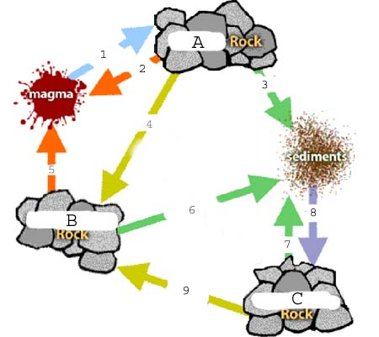
Target 8:
Identify the type of rock:
A:________________________
B:________________________
C:________________________
Identify the processes:
1:________________________
2:________________________
3:________________________
4:________________________
5:________________________
6:________________________ 7:________________________
8:________________________ 9:________________________

Rocks and Minerals
Chapter 8, pages 301 – 345 and pages 94-96
Create flashcards for these vocabulary terms. Some definitions have been given to you below.

Pages 94-96
-Mineral – a naturally occurring, inorganic solid with a definite chemical composition and an
orderly arrangement of atoms
-Luster
-Mohs’ Hardness Scale
-Hardness
-Streak
-Color – a property of minerals that you can observe with the unaided eye

Section 8.1
-rock
-magma
-lava
-sediment
-rock cycle

Section 8.2
-igneous rock – rock formed from magma or lava that has been cooled and hardened
-extrusive rock – igneous rocks that form as lava cools and hardens on the surface of earth
-2 examples of extrusive rock – page 315 and 317
-intrusive rock – igneous rocks that form as magma cools and hardens underground
-2 examples of intrusive rock – page 317

Section 8.3
-sedimentary rock – rock formed from deposition, compaction and cementation of sediments
-deposition – the laying down (or depositing) of sediments
-compaction
-cementation
-clastic rock (give definition and an example)
-chemical rock (give definition and an example)
-biochemical rock (give definition and an example)

Section 8.4
-metamorphic rock – rock formed from extreme temperature and pressure deep inside earth
-foliated rocks (give definition and an example)
-nonfoliated rock (give definition and an example)

