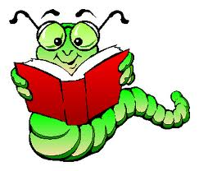
Classifying Matter Vocabulary Learning Check
Use the flashcards you created to write the vocabulary term in the correct blank.
ductility 1. ability of a substance to be pulled into thin wires
malleability 2. ability of a substance to be hammered or rolled into sheets
matter 3. anything that has mass and takes up space
semi metals 4. another term for metalloid
semi conductor 5. conducts electricity at high temperatures but not at low temperatures
luster 6. describes the ability of a metal to reflect light
nonmetals 7. elements that have no metallic properties
metals 8. elements that are generally shiny and is easily pulled into wires or hammered into sheets
metalloids 9.element that has physical and chemical properties of both metals and nonmetals
mixture 10. matter that can vary in composition, made from two or more substances that are not chemically combined
element 11. pure substance made of only one kind of atom
atom 12. small particle that is the building block of matter, made up of protons and neutrons in the nucleus with electrons orbiting the nucleus
conductor 13. substance that allows heat or electricity to pass through it; a physical property of metals
insulator 14. substance that does not allow heat or electricity to pass through it; a physical property of non-metals
compound 15. substance made of two or more elements that are chemically joined in a specific combination
molecule 16. two or more atoms that are held together by chemical bonds and act as a unit

